**Lab Exercise 7: Creating Multiple IAM Users in Terraform**

**Objective:**

Learn how to use Terraform to create multiple IAM users with unique settings.

**Prerequisites:**

* Terraform installed on your machine.
* AWS CLI configured with the necessary credentials.

**Steps:**

**1. Create a Terraform Directory:**

Bash

mkdir terraform-iam-users

cd terraform-iam-users

**2. Create Terraform Configuration Files:**

**a. Create a file named** main.tf**:**

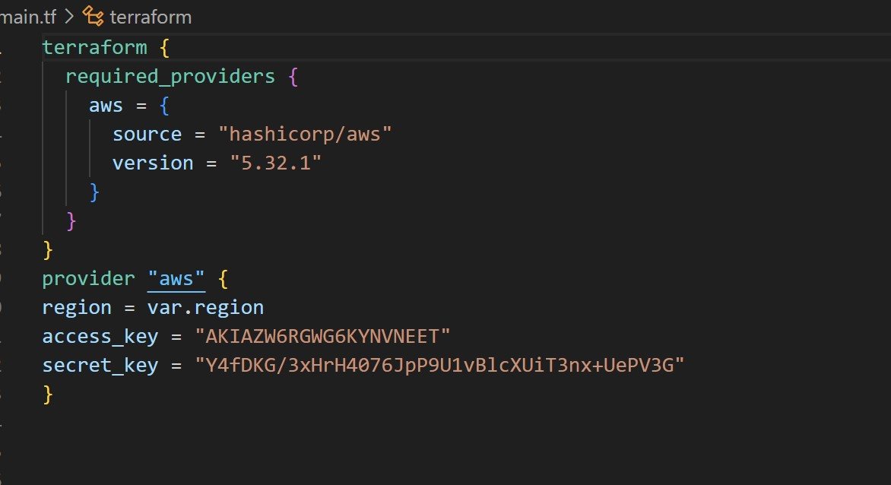

Variable.tf

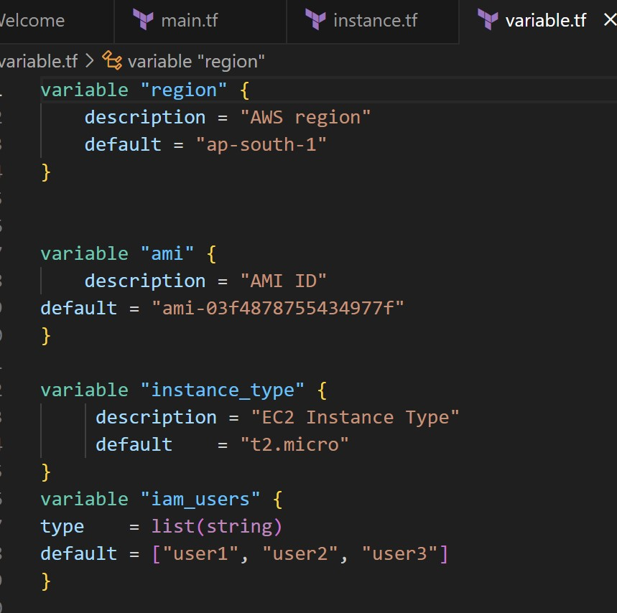

Instance.tf

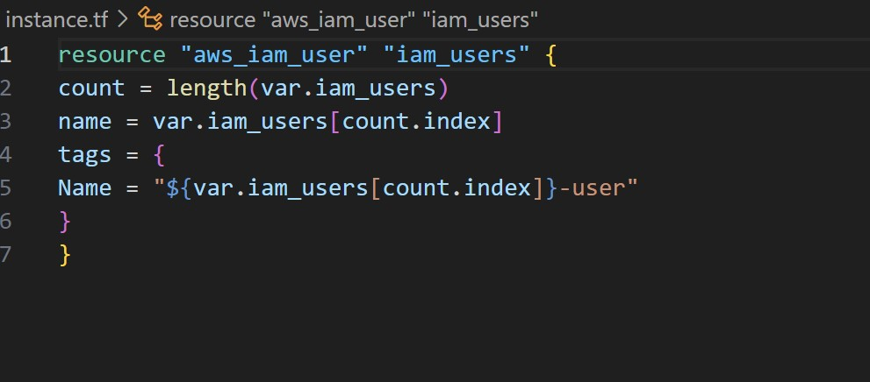

**3. Initialize and Apply:**

terraform init

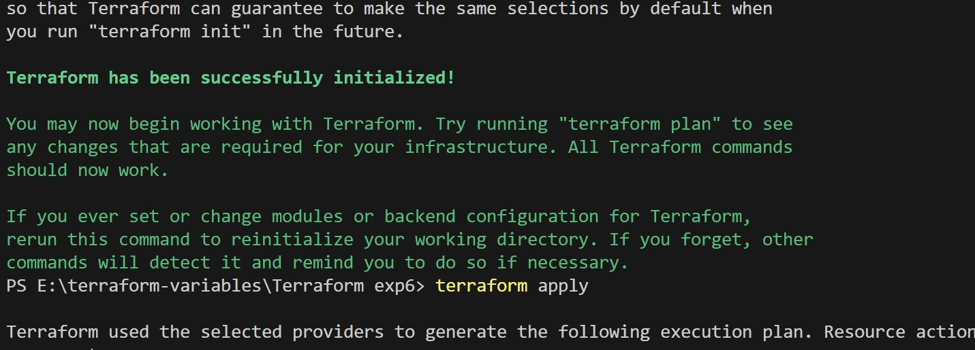

terraform apply

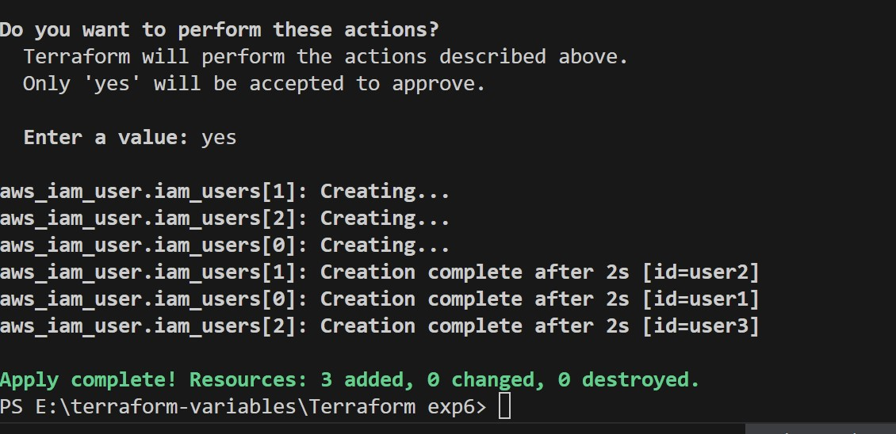

**Explanation:**

* The terraform init command initializes the Terraform configuration and downloads the necessary AWS provider plugins.
* The terraform apply command creates the IAM users based on your Terraform configuration. You will be prompted to confirm the creation of the users. Type yes and press Enter to proceed.

**4. Verify Users in AWS Console:**

1. Log in to the AWS Management Console.
2. Navigate to the IAM service.
3. Verify that the IAM users with the specified names and tags have been created.
4. 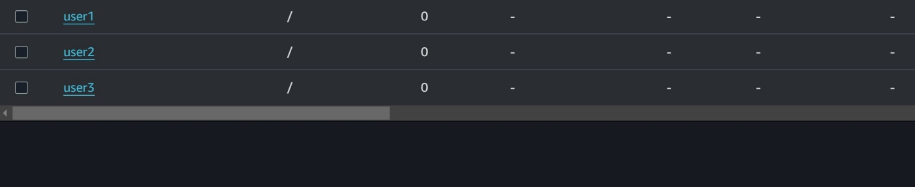

**5. Update IAM Users (Optional):**

* If you want to add or remove IAM users, modify the iam_users list in the main.tf file.
* Run terraform apply again to apply the changes.

**6. Clean Up (Optional):**

* After testing, you can clean up the IAM users by running:

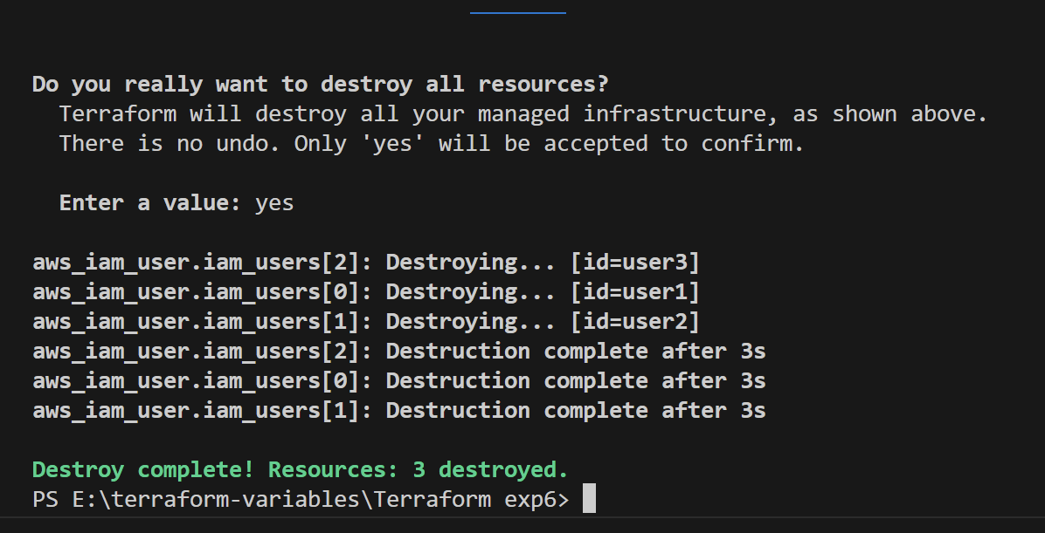

Bash

terraform destroy

* Confirm the destruction by typing yes.

**Conclusion:**

This lab exercise demonstrates how to use Terraform to create multiple IAM users in AWS with unique settings. By using variables and loops, you can easily manage and scale the creation of IAM users. Experiment with different user names and settings in the main.tf file to understand how Terraform provisions resources based on your configuration.